# Angular

**Materials and resources:**

<https://angular.io/docs>

<https://cli.angular.io/>

<https://www.dunebook.com/from-zero-to-hero-learn-angularstrap-from-scratch/>

<http://www.netinstructions.com/100-days-of-angular-2/?utm_source=mybridge&utm_medium=web&utm_campaign=read_more>

<https://github.com/johnpapa/angular-styleguide/blob/master/a2/README.md>

<https://legacy.gitbook.com/book/basarat/typescript/details>

<https://basarat.gitbooks.io/typescript/>

<https://www.youtube.com/watch?v=qRD7bkK7m10>

<https://thinkster.io/tutorials/learn-angular-2>

<https://www.tutorialspoint.com/angular2/>

Books: ng-book2-r37

## Assignments:

Task 1: Implement ‘Portal view page’

Here on this page user can read more about the product and can add the product to the shopping cart. The user manually can edit the number of products.

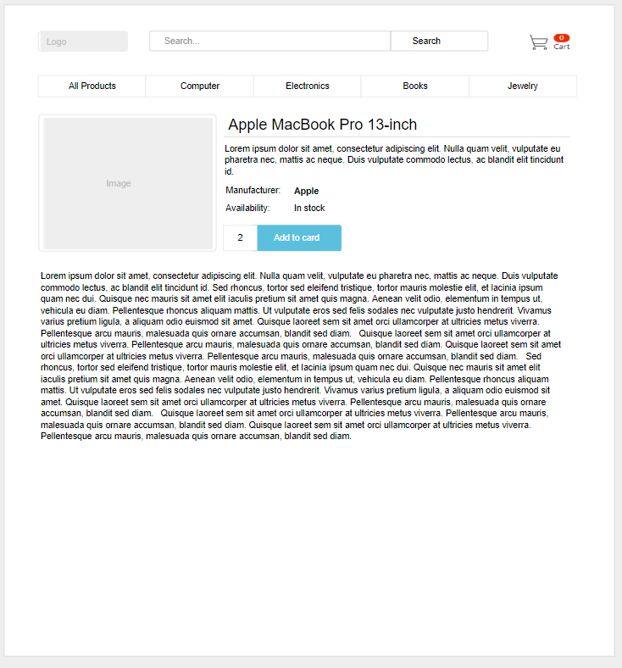

Portal: Product view page

Task 2: Implement ‘Shopping card page’

On this page, the user can change the number of items that he wants to buy in Quantity row. He also can remove the product from the Shopping card, by clicking on ‘Remove’ button. Toast message is displayed when a user clicks on 'Checkout' button and user is redirected to the 'Home' page.

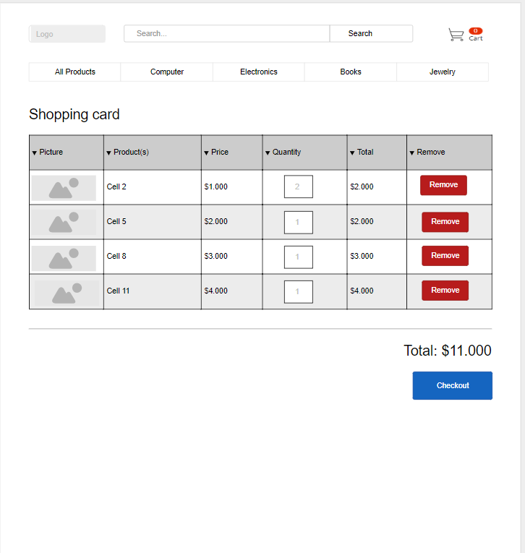

Portal: Shopping card page